

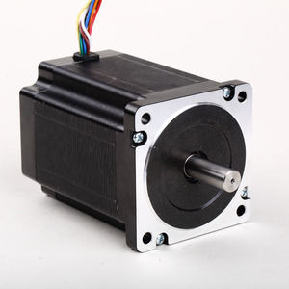

#### 86mm Hybrid Stepper Series

**SPECIFICATIONS:**

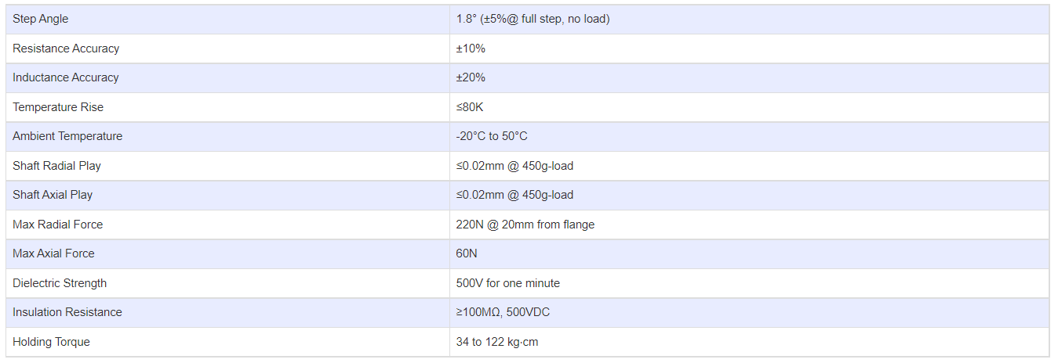

**SUBMODELS:**

*The following are common submodels for the LDO-86STH series.*

